Erin Swinson
CS 340
Tim Hawkins
April 19, 2026
CS 340 README Project Two
Overview of Functionality
This project implements a full CRUD (Create, Read, Update, Delete) Python module and an interactive dashboard application for the Austin Animal Center MongoDB database. The CRUD module provides reusable database operations through the AnimalShelter class, while the dashboard allows the client, Grazioso Salvare, to filter, visualize, and interact with AAC animal outcome data in real time.
Required Components
Filter options via radio‑button controls that allow the user to select specific rescue categories (Water Rescue, Mountain/Wilderness Rescue, Disaster/Individual Tracking, or Reset). These filters trigger MongoDB queries through the CRUD module and dynamically update all dashboard widgets.
Interactive data table to display the filtered AAC dataset with support for sorting and row selection. The table updates automatically based on the selected rescue filter and serves as the data source for the charts and map.
A geolocation map that plots the location of the selected animal using latitude and longitude fields from the dataset. Selecting a row in the data table updates the map marker and popup information.
A secondary pie chart for a visual summary of breed distribution for the currently filtered dataset. The chart updates automatically whenever the data table changes.
Branding elements where the dashboard includes the Grazioso Salvare logo and a unique identifier to meet client and project requirements.
Motivation
This project was developed as part of a CS 340 course assignment designed to give experience on creating reusable Python code that interacts with a NoSQL database by implementing Create, Read, Update, Delete operations. This CRUD module then served as the foundation for developing a dashboard for user interfacing. Which gave additional experience in dashboard development and data visualization.
Documenting Tools and Rationale
MongoDB was selected because it uses a flexible, document-oriented schema. This allows the Austin Animal Center dataset to store varying fields across different animal records without requiring a rigid relational structure. The BSON/JSON format also integrates naturally with Python dictionaries.
PyMongo is the official MongoDB driver for Python. It provides direct access to MongoDB’s CRUD operations and supports features such as projections, update operators, and BSON handling. It is recommended by MongoDB’s documentation and integrates cleanly with Python classes.
Python was chosen for its readability, ease of use, and strong ecosystem of data-handling libraries. The CRUD module is implemented as a reusable Python class [AnimalShelter] to support modularity and future integration into applications such as dashboards.
Step Taken to Complete the Project
Implementing the CRUD Python Module (See How CRUD Methods were Created)
The project began with the creation of the AnimalShelter class, which encapsulates all Create, Read, Update, and Delete operations for the Austin Animal Center MongoDB database. Each method was designed to map directly to MongoDB operations, including input validation, and return predictable results. This module serves as the data-access layer for the dashboard.
Setting up the MongoDB Environment
MongoDB Community Server was installed and configured locally. The AAC dataset was imported into the aac.animals collection, and the aacuser account was created with read/write permissions.
Creating the Dashboard Structure in JupyterDash
The ProjectTwoDashboard.ipynb file was used to build the dashboard layout. This included placing the Grazioso Salvare logo, adding a unique identifier, and creating the main dashboard sections such as filter controls, data table, geolocation map, and a secondary chart.
Developing the Interactive Filter Options
Radio‑button controls were added to allow the user to select between Water Rescue, Mountain/Wilderness Rescue, Disaster/Individual Tracking, or Reset and set up in a way that matches the client’s provided example. These options were designed to be intuitive for the client and directly tied to MongoDB queries through the CRUD module.
Building the Database Query Logic
A query function was created to translate each rescue type into a MongoDB query. These queries filter the AAC dataset based on breed lists and rescue criteria provided in the Dashboard Specifications Document. The dashboard uses the CRUD module’s read() method to retrieve the filtered data.
Creating the Interactive Data Table
A Dash DataTable was implemented to display the AAC dataset. It supports sorting, pagination, and row selection. The table updates dynamically whenever a filter is selected, and it serves as the data source for the map and pie chart.
Implementing the Geolocation Map
A dynamic map so when the user selects a row in the data table, the map updates to show the animal’s location using latitude and longitude fields. The map marker and popup text change automatically based on the selected record.
Adding the Secondary Pie Chart
A pie chart was added to visualize breed distribution for the currently filtered dataset. The chart updates automatically whenever the data table changes, ensuring that it always reflects the active rescue filter.
Testing and Verification
(See Challenges)
How CRUD Methods were Created
The CRUD module was created using object‑oriented programming principles to encapsulate all database interactions inside a single reusable class. Each CRUD method was designed to map directly to MongoDB operations while maintaining clear input validation and error handling.
Create
The create() method accepts a Python dictionary and inserts it into the [animals] collection using insert_one(). It returns True if the insert was successful. This mirrors MongoDB’s document‑based structure and ensures only valid dictionaries are inserted.
Read
The read() method accepts a query dictionary and returns a list of matching documents using find(). It was designed to return an empty list for invalid queries to prevent errors. Optional projection support can be added to limit returned fields.
Update
The update() method uses update_many() with the $set operator to modify fields in matching documents. It returns the number of modified documents, allowing the user to verify whether the update was successful.
Delete
The delete() method uses delete_many() to remove documents matching the query. It returns the number of deleted documents and raises an exception if no query is provided to prevent accidental mass deletion.
Usage
Code Example: From Updating documents in the CRUD file
# Use the update function to query for and change document(s) for the U of CRUD
def update(self, query, new_values):
if query is None or new_values is None:
raise Exception("Error: Value is not present to make changes to.")
try:
result = self.database.animals.update_many(query, {"$set": new_values})
return result.modified_count
except Exception as e:
print("Error:", e)
return 0
Reproducing the Project
Required tools
MongoDB Community Server hosts the AAC database and stores the animals collection.
Python 3 is used to write and run the CRUD module and dashboard.
JupyterLab is used to run the test script and the dashboard.
PyMongo is the official MongoDB driver for Python for CRUD operations.
Dash is used to build and run the interactive dashboard.
Getting started
Start your MongoDB server.
Confirm the aac database and animals collection already exist.
Import the Austin Animal Center dataset into MongoDB if needed.
Create the aacuser account with read/write permissions.
Confirm authentication using your chosen username and password.
Ensure the user has the correct role (Read/Write on acc database).
Make sure your directory includes CRUD_Python_Module.py, ProjectTwoDashboard.ipynb, and the Grazioso Salvare logo file. (Optional: Test Scripts from Module Four and Project One).
Open ProjectTwoDashboard.ipynb in JupyterLab.
Run all cells to start the Dash server.
The dashboard will load in your notebook environment.
Use the interactive filter options (radio items) to retrieve data from MongoDB.
The data table, pie chart, and geolocation map will update based on selections.
Challenges
Some rescue filters returned very small datasets, and in some cases, the user may select a row that does not contain valid latitude or longitude values. Error handling and safe defaults were added to prevent the dashboard from crashing and to ensure the map always displays a valid marker.
Plotly automatically adjusts the chart layout when many slices are present, which caused the chart to appear distorted or cone‑shaped. This was resolved by explicitly setting hole=0, forcing labels inside the slices, and adjusting layout margins and text settings to override Plotly’s auto‑scaling behavior.
Dash and Plotly can behave unpredictably when receiving empty datasets or when callbacks fire before the data table is fully populated. This was resolved by adding checks for None, empty lists, and missing fields before rendering the widgets.
Known Issues
Dashboard does not refresh until a table selection is made. The map and pie chart rely on the DataTable’s derived_virtual_data and derived_virtual_selected_rows. Because of this, the dashboard does not fully refresh the map marker until the user selects a row in the table. This is expected behavior in Dash when using the DataTable as the central data source.
Map and pie chart load slowly. When large datasets are returned (such as when the Reset filter is selected), the pie chart and map may take several seconds to render. This is due to the size of the AAC dataset and the processing required by Plotly and Dash Leaflet. The dashboard remains functional, but users may notice a delay.
Screen Shots
Database Commands (Mongo Shell and Screenshots):
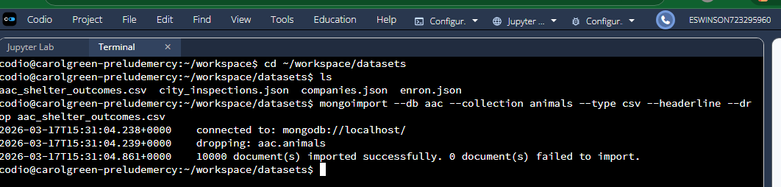
Austin Animal Center (AAC) Outcomes data set loaded into MongoDB.1
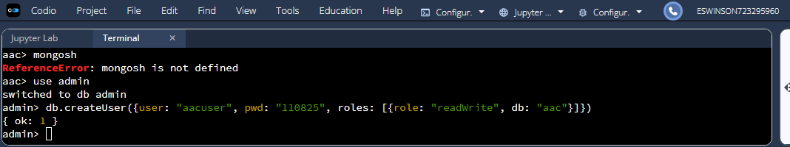
Created a user account called “aacuser” with read and write access. 2
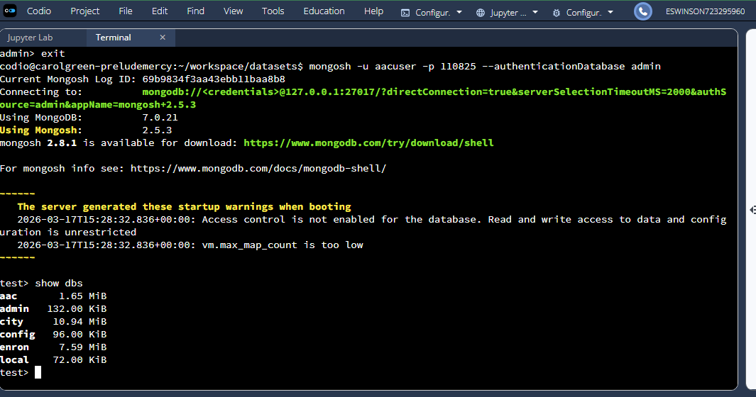
Login process to MongoDB using the mongo shell.3
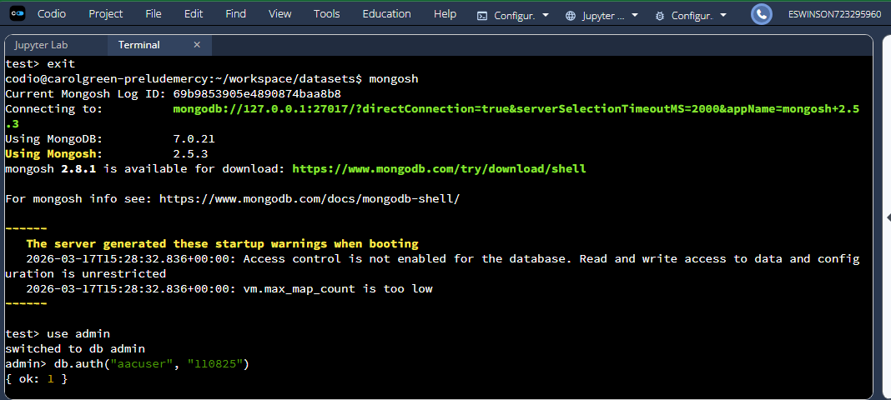
Showing successful connection by running db.runCommand({connectionStatus:1}) 4
CRUD Python Module (Python Code and Screenshots):
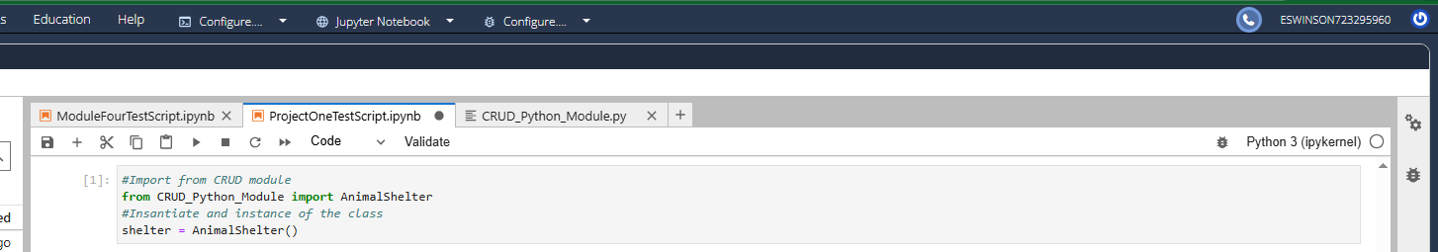
Import Crud Module functionality is demonstrated by all other reliant tests 5
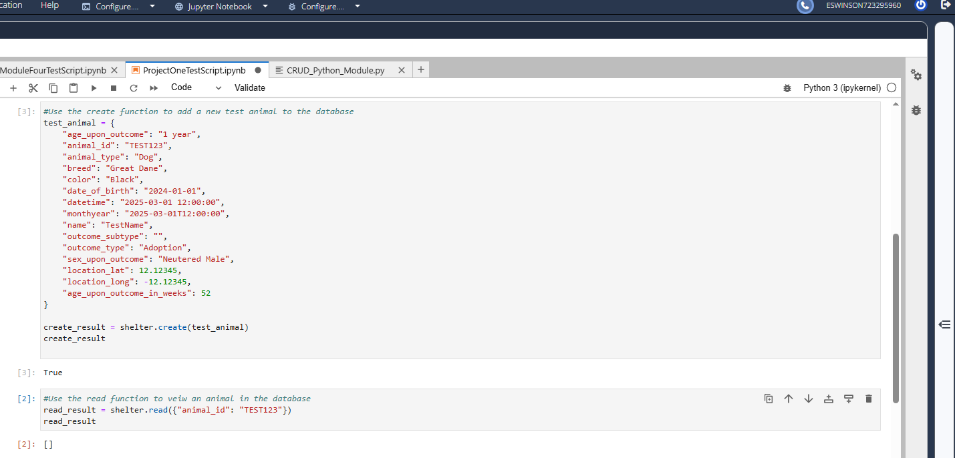
Run read before insert shows an empty data set 6
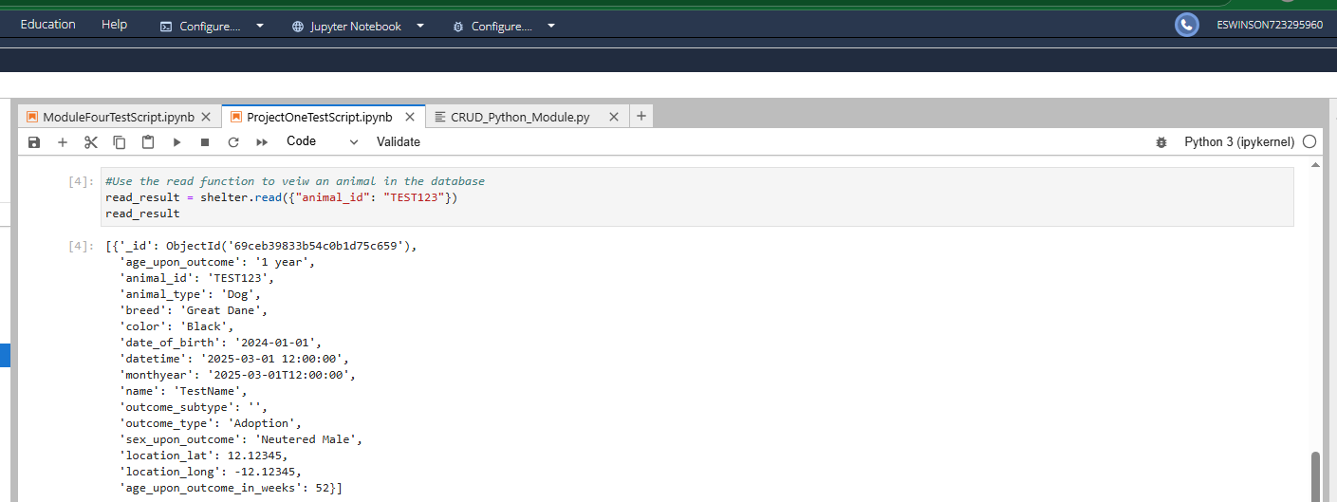
Running the read function after write shows the document was successfully added 7
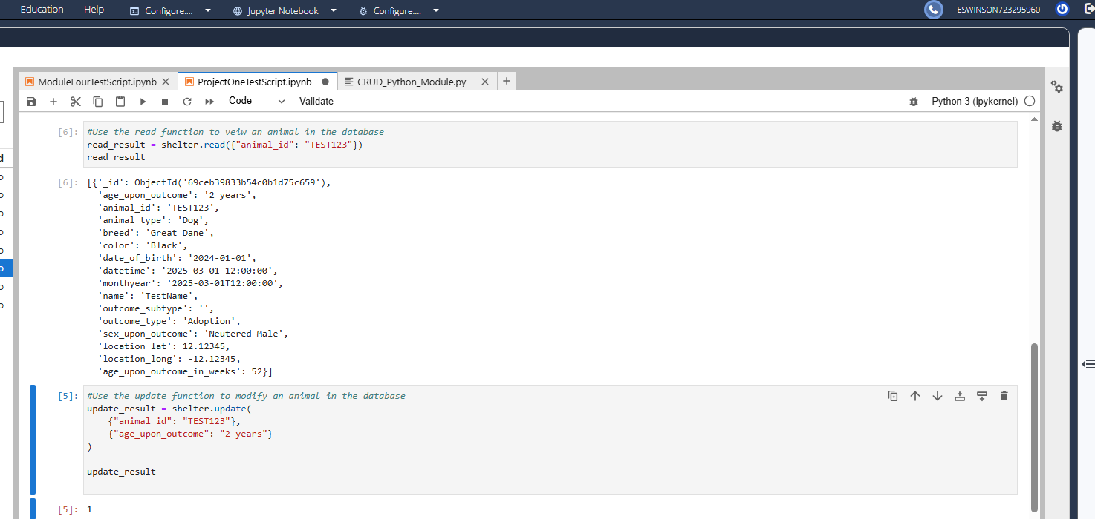
Running the read function after update shows the expected document change 8
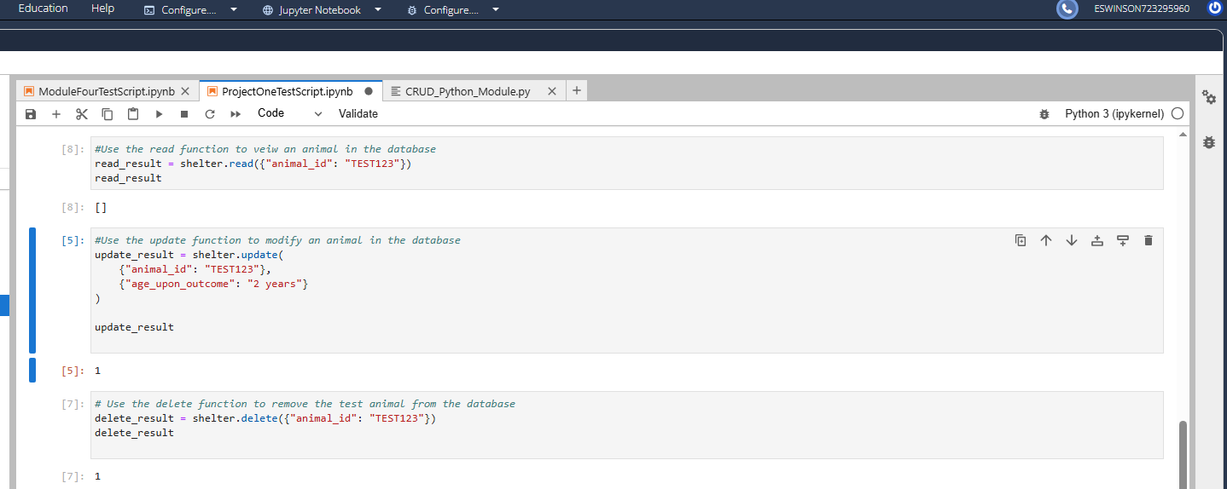
Running read after using the delete function returns an empty set again 9
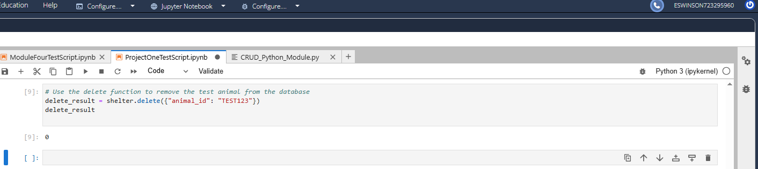
Running delete again on the same document returns 0 (No documents affected) 10
Dashboard Functionality Screenshots
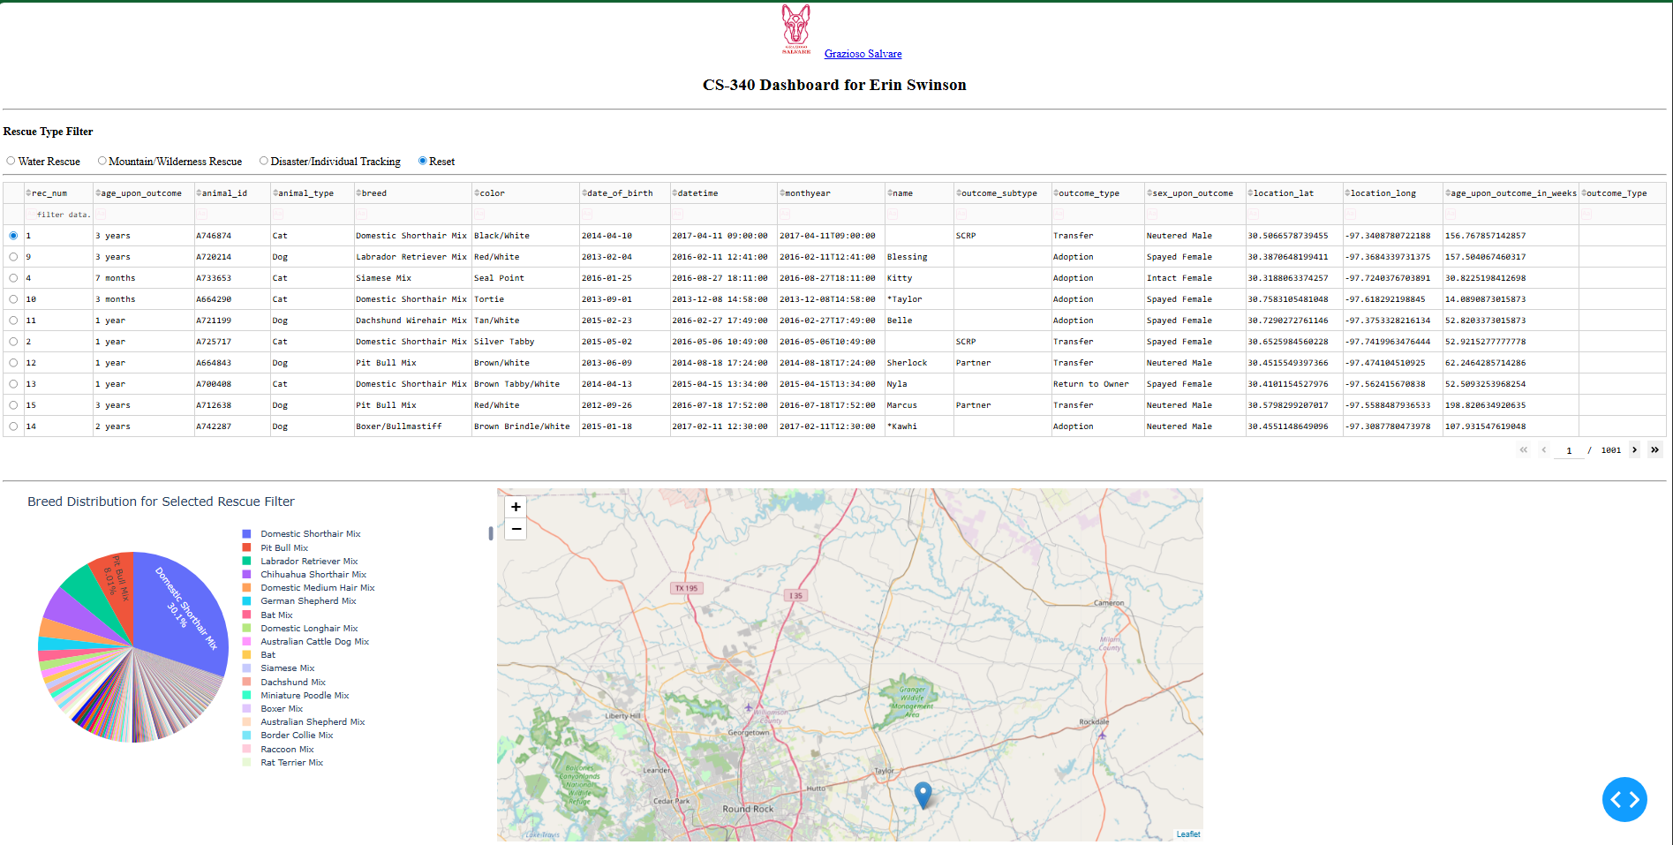
Functionality- opening page 11
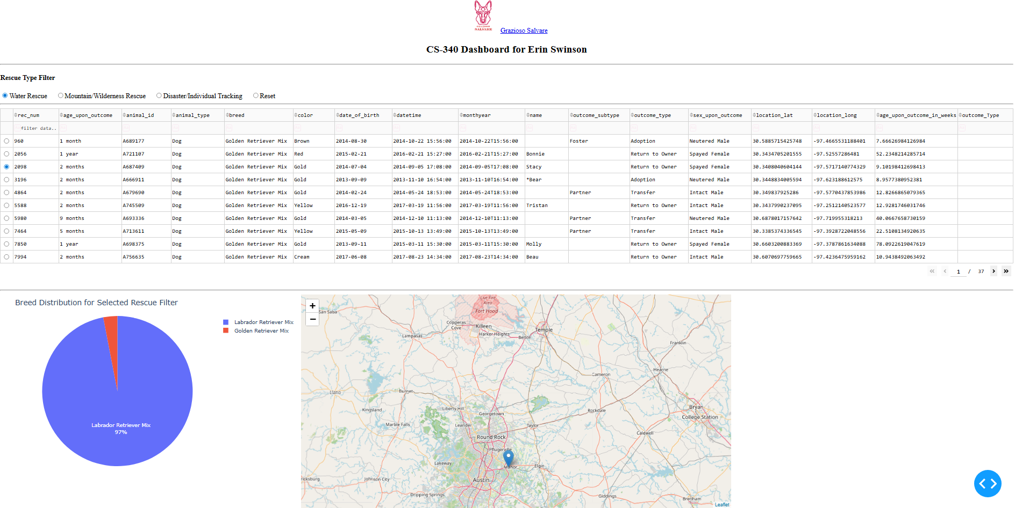
Functionality – Water Rescue sort (Updated all data) 12
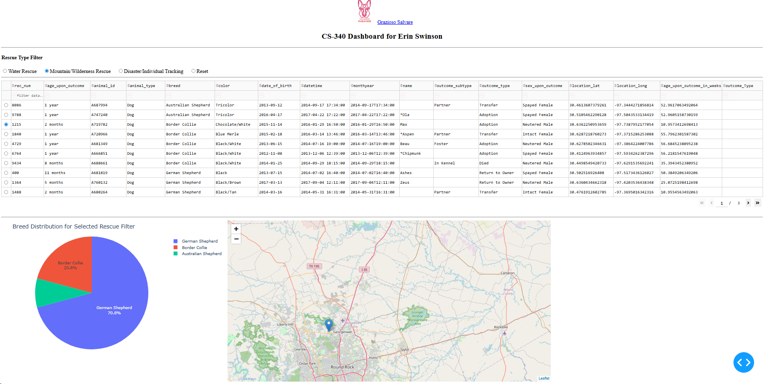
Functionality- Mountain/Wilderness Rescue 13
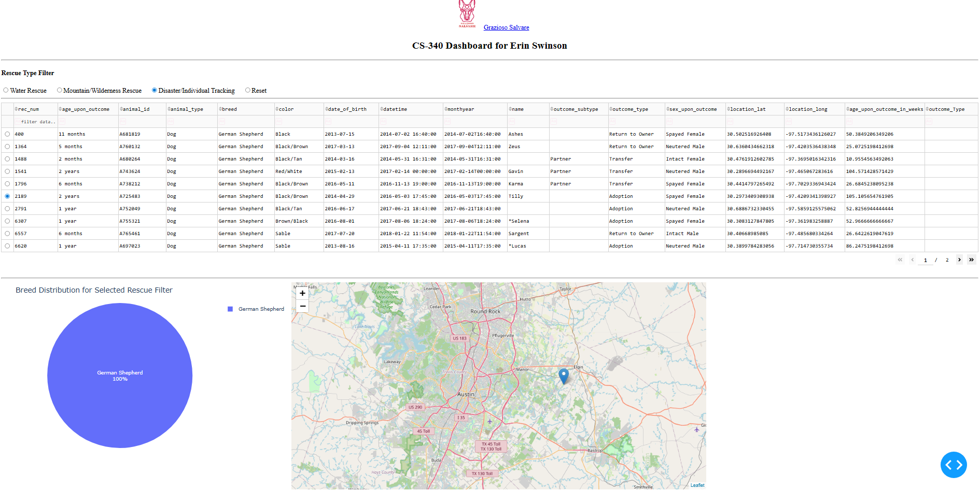
Functionality- Disaster/Individual Tracking 14
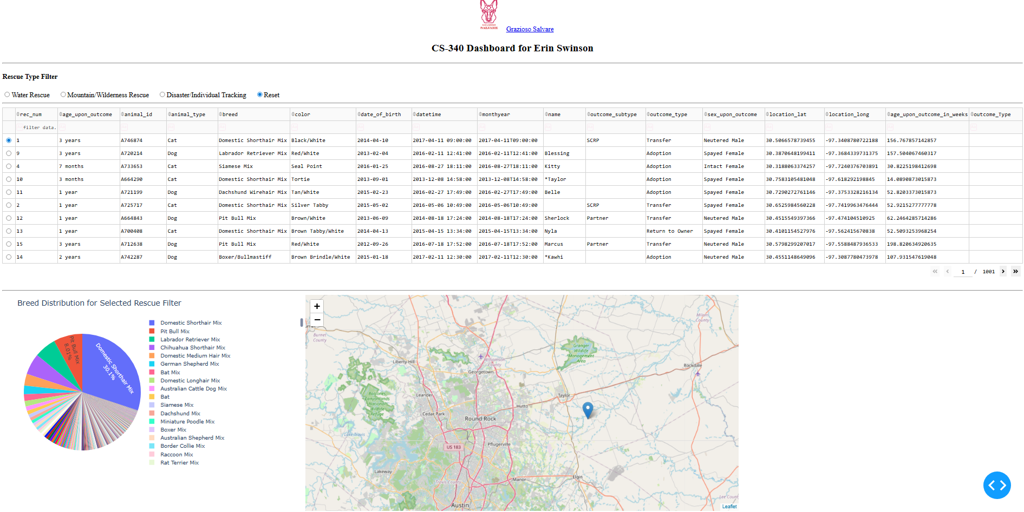
Functionality- Reset (Reverts all data) 15

References
Barry, P. (2016). Head first Python (2nd ed.). O’Reilly Media.
Make a README. (n.d.). Make a README. https://www.makeareadme.com/

